|  |
| --- |
| CONNECTED HOME ENVIRONMENT SYSTEM    Report Submitted for Review II  **Submitted by: Guided by:**  N PRUDHVI REDDY Ashline George &  141FA05099 Dhanasudakar Vasudevan  (signature) |

**ABSTRACT**

The primary purpose of the “**CONNECTED HOME ENVIRONMENT SYSTEM** “is to monitoring indoor air quality and security of the home.

Security camera mainly helps to keep track of the people who visited home. Surveillance camera using raspberry pi is setup in the pin hole of the entrance door where you want to monitorvisitorsusing motion of that person and stream video containing the motion and stored in the cloud and accessed remotely using a mobile application.

Indoor air quality monitoring device will monitor different types of gas levels detected in the home. Mainly gases like carbon dioxide, oxygen, LPG levels are detected and this data can be viewed using mobile application with an access to the cloud. If the temperature level exceeds then it will send a notification to the mobile application which can be viewed remotely.

## Introduction

Connected home is to monitor the home Indoor Air Quality (IAQ) and providing security using camera.

Indoor Air Quality is to monitoring the gases in the home environment using sensors which is connected to raspberry pi and continuous monitoring data is send to the cloud and Android App. where ever there is exceed in the Air quality like if gas leakage (LPG) and more percentage of CO2 these sensors will notify the user.

Security camera will monitor the visitors who are coming to home and send the notification if any visitor visits home to user by Android App and mail. It will works on motion of the person in front of the camera.

## Objective

Main purpose is to continuous monitor the Indoor Air Quality and security of the home. It should notify the user by an app or mail service.

By using Raspberry pi as controller it will send data to cloud. Whenever there is a visitor or an intruder in front of the house it will notify the user so that there will be minimal damage if there is intruder (thief) user can notify to police as soon as possible.

Using sensor data user can know what is Air quality in the home even if he in the office. There are many cases that we may thought that whether we turn off the LPG or not so this will help to check whether it is on or off.

## Architecture

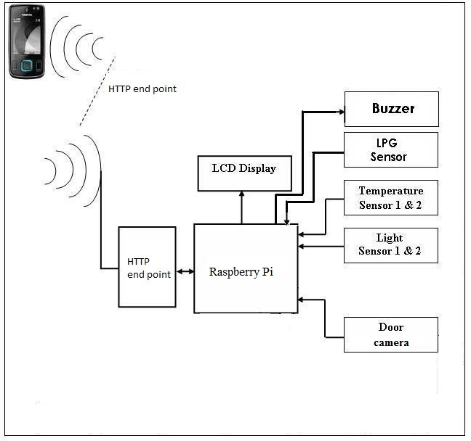

## Android App

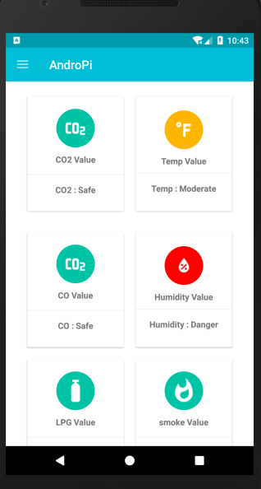

## Hardware Components

1. Raspberry pi
2. USB Camera
3. MQ-2
4. MQ-135
5. DHT-22

## Software Requirements

1. Python
2. Motion Lib
3. Rasbian OS
4. Azure cloud storage

## Work done

1. Sending the pictures to cloud and mail service is done
2. Reading and sending the sensor data to cloud is done

## Work To Be Completed

1. Developing the Android App (60% is done) need to fetch data from cloud
2. Designing the box for the product

## References

[1] https://circuitdigest.com/microcontroller-projects/raspberry-pi-surveillance-camera*.*

[2] http://www.raspberry-projects.com/pi/software_utilities/email/ssmtp-to-send-emails

[3] https://tutorials-raspberrypi.com/configure-and-read-out-the-raspberry-pi-gas-sensor-mq-x/

[4] http://www.instructables.com/id/Raspberry-PI-and-DHT22-temperature-and-humidity-lo/

[5] https://docs.microsoft.com/en-us/azure/storage/